GUADELEST

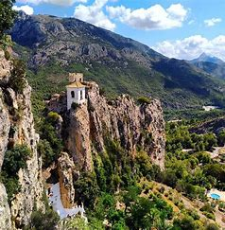

<https://realestateagentspain.com/sv/guadalest-sv/>

[Karta Guadelest](https://www.google.com/maps/place/03517+Guadalest,+Alicante,+Spanien/@38.6351535,-0.2748419,11.58z/data=!4m5!3m4!1s0xd61f647011b36e1:0x1415cabf319b5ca4!8m2!3d38.6769639!4d-0.1983236)

COLL DE RATES Rövarpasset

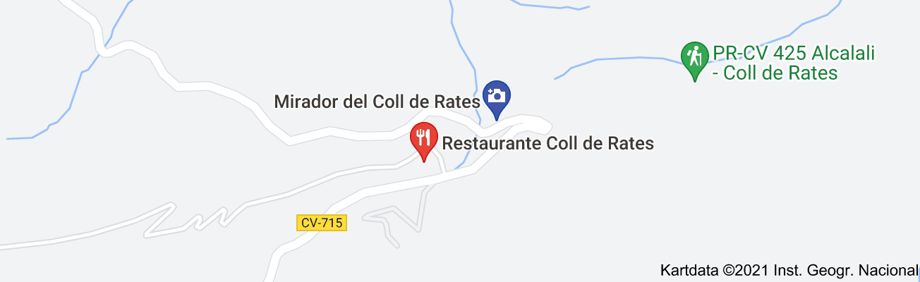

FUENTES DE L’ALGAR

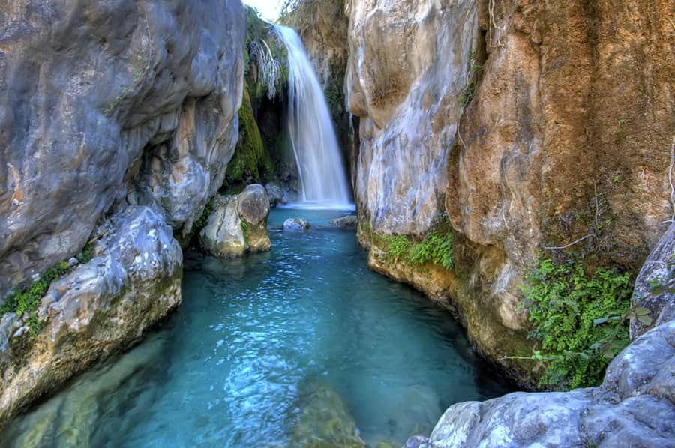

[Karta Fuentes de lÁlgar](https://www.google.com/maps/place/Fonts+de+l'Algar/@38.6604652,-0.0948788,15z/data=!4m2!3m1!1s0x0:0x8bc5c3fbd5537413?sa=X&ved=2ahUKEwjr0Z72093zAhUriYsKHXtSBocQ_BJ6BQiJARAF)

ALTEA LA VELLA

Restaurang Mallol Tel. +34 9 6584 8047

[Pierna de Cordero al horno](https://www.google.com/maps/place/Restaurante+Mallol/@38.6312408,-0.0445619,3a,75y,90t/data=!3m8!1e2!3m6!1sAF1QipPasPcT-B6kJJGRsD8-GgBWcaQjnR9Z9ARJ_Uma!2e10!3e12!6shttps:%2F%2Flh5.googleusercontent.com%2Fp%2FAF1QipPasPcT-B6kJJGRsD8-GgBWcaQjnR9Z9ARJ_Uma%3Dw205-h100-k-no!7i1600!8i777!4m11!1m2!2m1!1sRestauranger!3m7!1s0xd6201b651990f17:0xa4b2cbc1e8656726!8m2!3d38.6312408!4d-0.0445619!14m1!1BCgIYIA!15sCgxSZXN0YXVyYW5nZXJaDiIMcmVzdGF1cmFuZ2VykgEYbWVkaXRlcnJhbmVhbl9yZXN0YXVyYW50mgEkQ2hkRFNVaE5NRzluUzBWSlEwRm5TVU0wTkdOcFgzQlJSUkFC)

[Mos med vitlök och mandel](https://www.google.com/maps/place/Restaurante+Mallol/@38.6312408,-0.0445619,3a,75y,90t/data=!3m8!1e2!3m6!1sAF1QipOiDuPdEFWWqVfreHU0dMVjQ8ttgo9bme-HHXLy!2e10!3e12!6shttps:%2F%2Flh5.googleusercontent.com%2Fp%2FAF1QipOiDuPdEFWWqVfreHU0dMVjQ8ttgo9bme-HHXLy%3Dw205-h100-k-no!7i4032!8i1960!4m11!1m2!2m1!1sRestauranger!3m7!1s0xd6201b651990f17:0xa4b2cbc1e8656726!8m2!3d38.6312408!4d-0.0445619!14m1!1BCgIYIA!15sCgxSZXN0YXVyYW5nZXJaDiIMcmVzdGF1cmFuZ2VykgEYbWVkaXRlcnJhbmVhbl9yZXN0YXVyYW50mgEkQ2hkRFNVaE5NRzluUzBWSlEwRm5TVU0wTkdOcFgzQlJSUkFC)

Don Cayo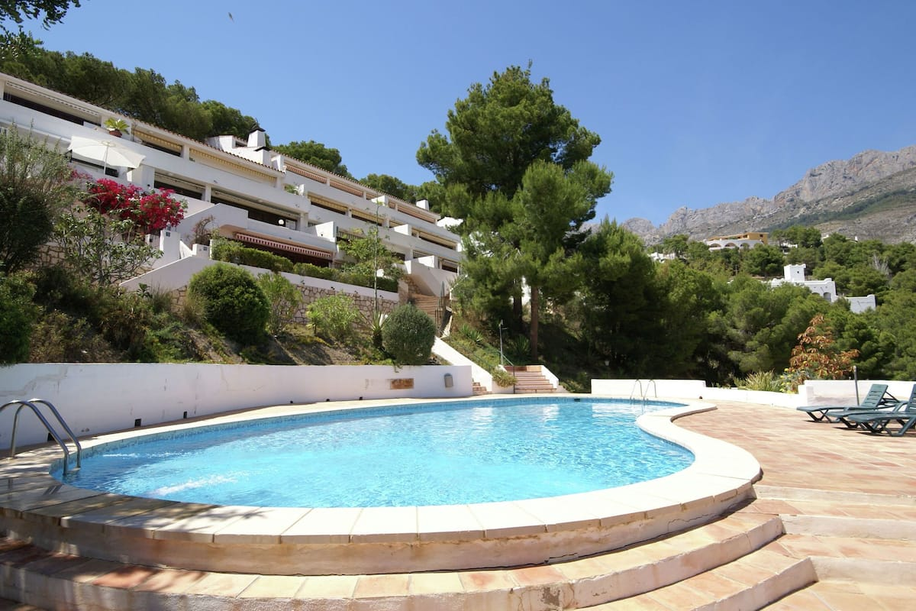

LA SOLANA Sjötunga Calle Naranjos, 1 Alcalalí (Alicante)Tel: 966 482 140

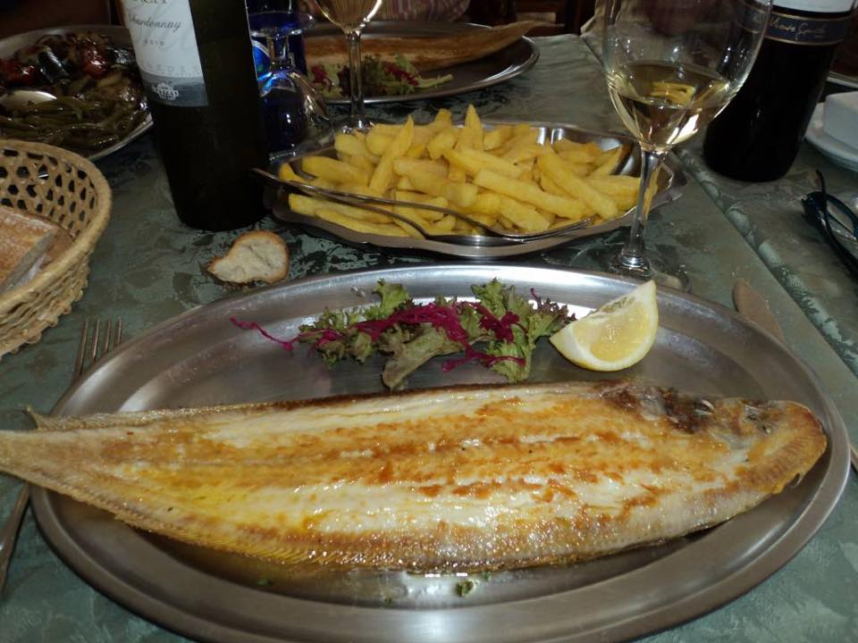

JALON Xalo´

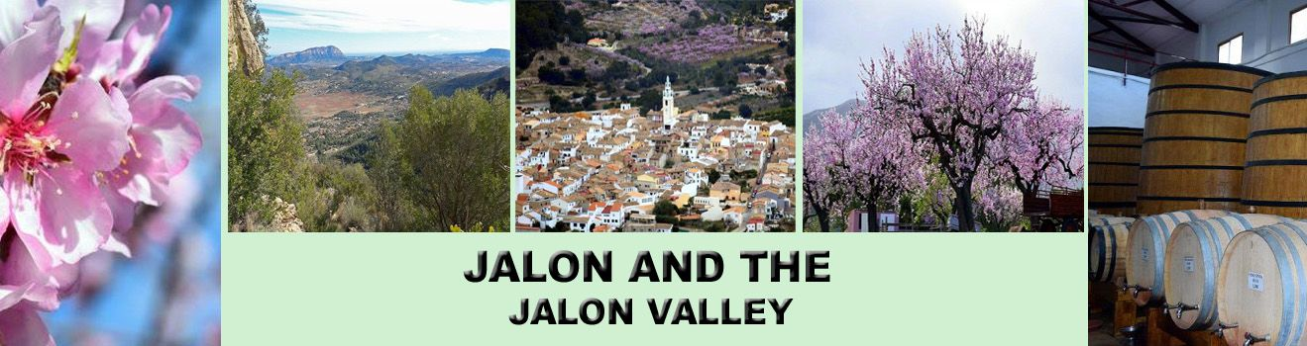

[Bodegas Rico](https://www.google.com/maps/place/Bodegas+Riko/@38.7429777,-0.0187679,15z/data=!4m13!1m7!3m6!1s0xd61fde3156ecb6b:0x6ea7a40936111667!2s03727+Jalón,+Alicante,+Spanien!3b1!8m2!3d38.7406537!4d-0.0110143!3m4!1s0xd61fde401626897:0x1ac875dc7347b50a!8m2!3d38.742443!4d-0.0138971) [Bodegas Xaló](https://www.google.com/maps/place/Bodegues+Xaló/@38.7429777,-0.0187679,15z/data=!4m13!1m7!3m6!1s0xd61fde3156ecb6b:0x6ea7a40936111667!2s03727+Jalón,+Alicante,+Spanien!3b1!8m2!3d38.7406537!4d-0.0110143!3m4!1s0xd61fc185785bdaf:0x1b4fe52c54ba3b9d!8m2!3d38.7441184!4d-0.0186529)

